All mosquito traps from summer 2017. Abundance standardized for time (3.5 hours)

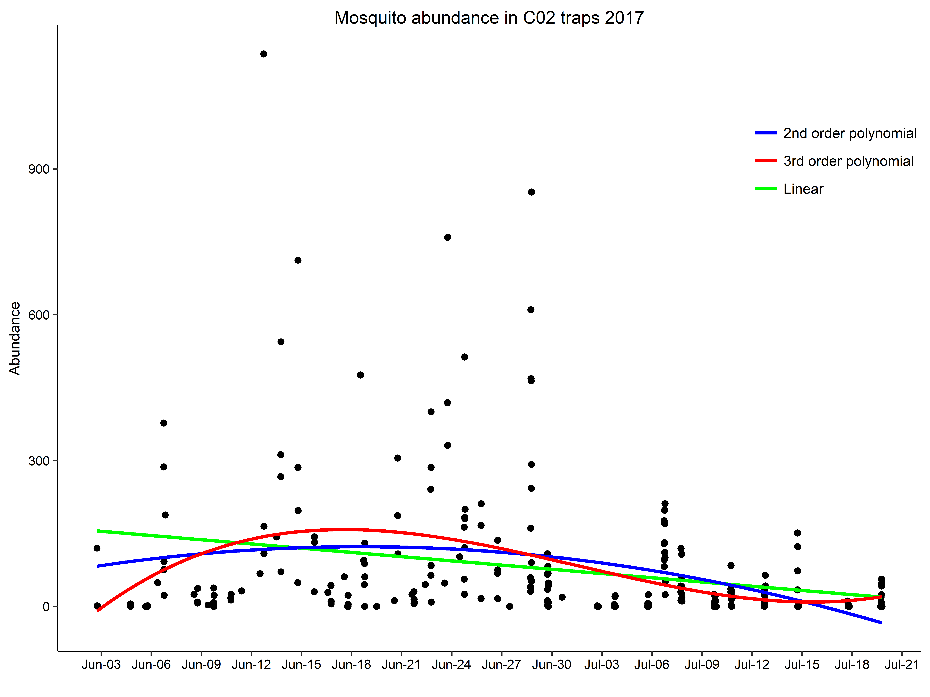

How does mosquito abundance change across 1) Time (Phenology) 2) Daily weather (flight activity) 3) landscape variation (blood meal density, quantity of larval habitat)

What distribution do the count data follow?

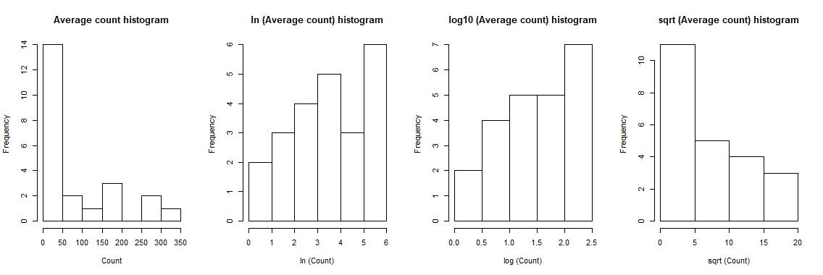

Count data follow a **zero inflated** **neg binomial distribution (or neg. binomial)**

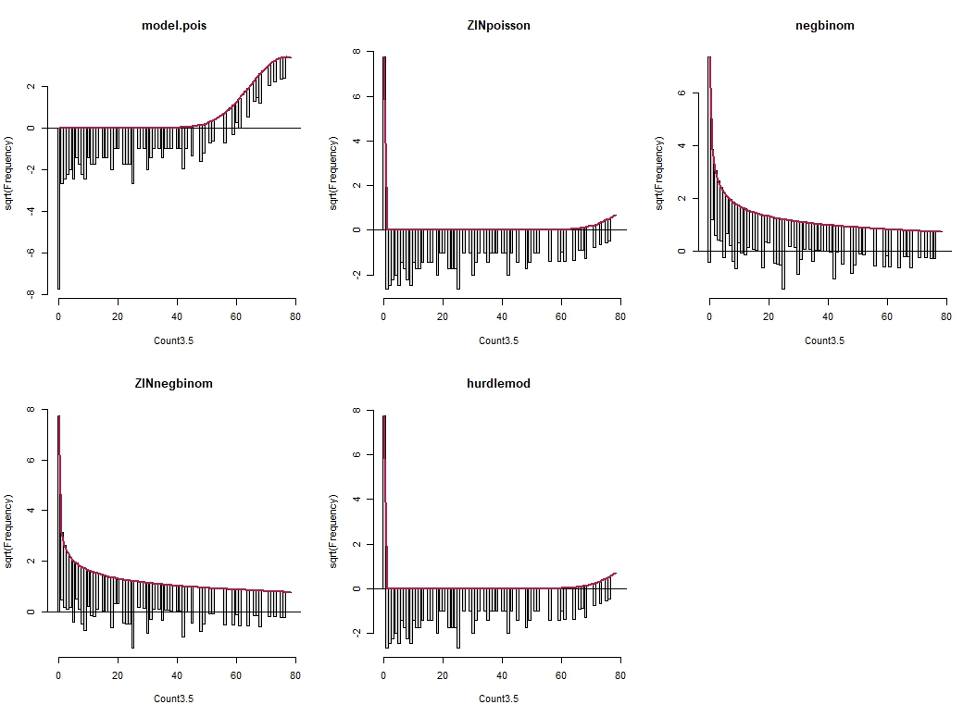

aictable(rawaic,nR)

Params logL AICc deltaAICc weight cumwt

ZINnegbinom 3 -1196.255 2398.605 0.0000 0.88 0.88

negbinom 2 -1199.271 2402.591 3.9856 0.12 1.00

null 2 -1627.648 3259.344 860.7390 0.00 1.00

hurdlemod 2 -16426.906 32857.859 30459.2542 0.00 1.00

ZINpoisson 2 -16426.906 32857.859 30459.2542 0.00 1.00

model.pois 1 -21582.176 43166.367 40767.7620 0.00 1.00

How does mosquito abundance change across 1) Time (Phenology)

Average counts across 4+ traps over 3.5 hours. Red = spline 3 knots, Blue = spline 4 knots

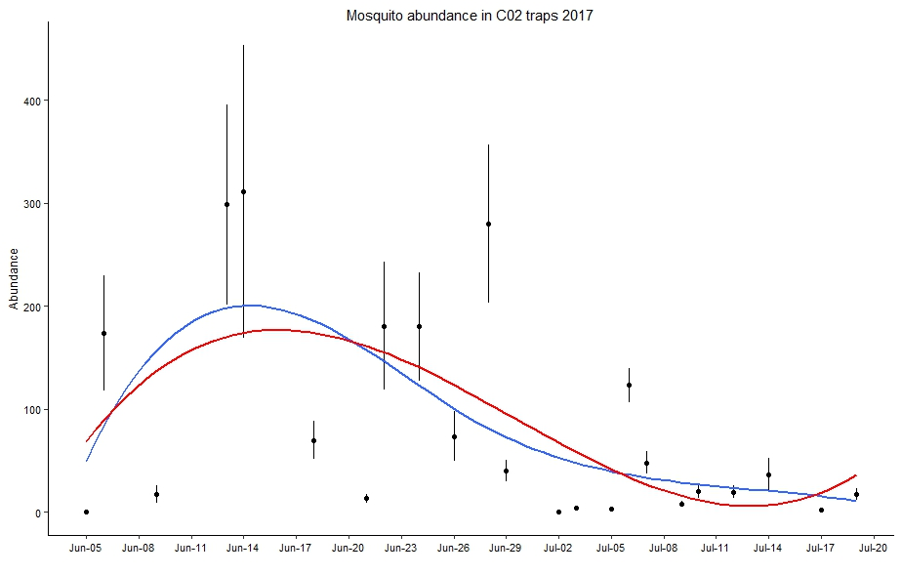

Same thing on a Ln scale . Red = spline 3 knots, Blue = spline 4 knots

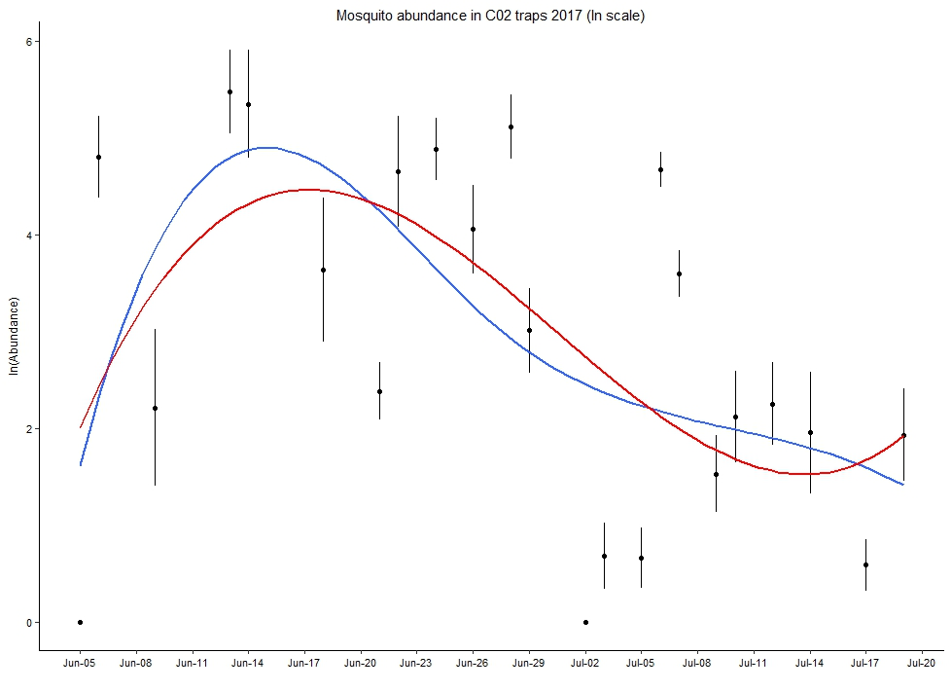

Try fitting spline functions to sites (close to town, away from town)

How does mosquito abundance change across) Daily weather (flight activity)

Histograms of weather variables during trapping times

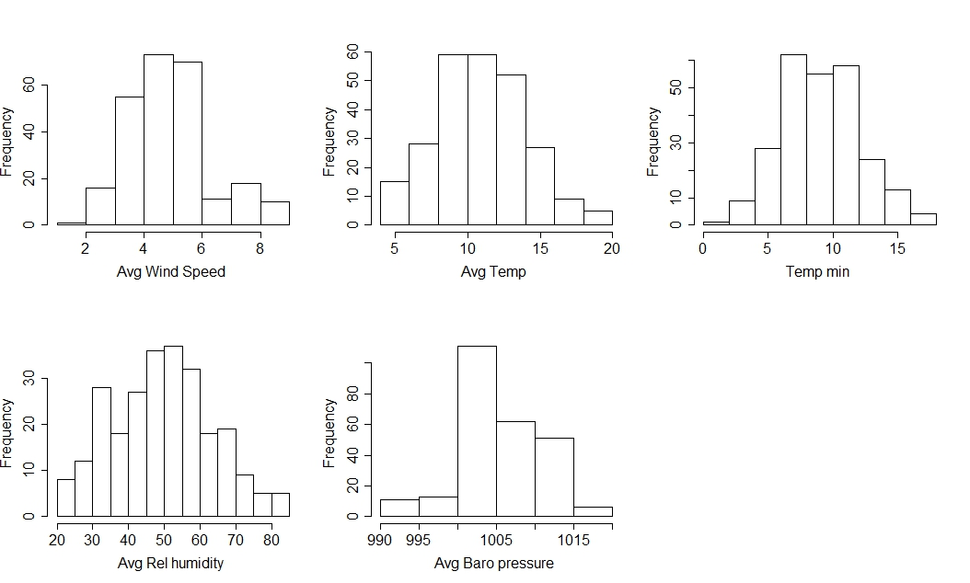

Correlations between weather variables (RH and temp are correlated, everything else looks okay)

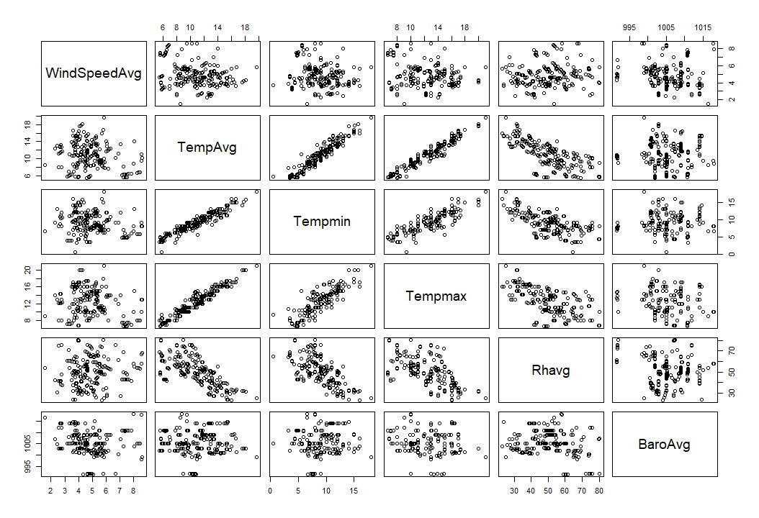

Convert RH to vapor pressure (combine with Baro pressure)

How does mosquito abundance change across) Daily weather (flight activity)

Moz abundance according to weather

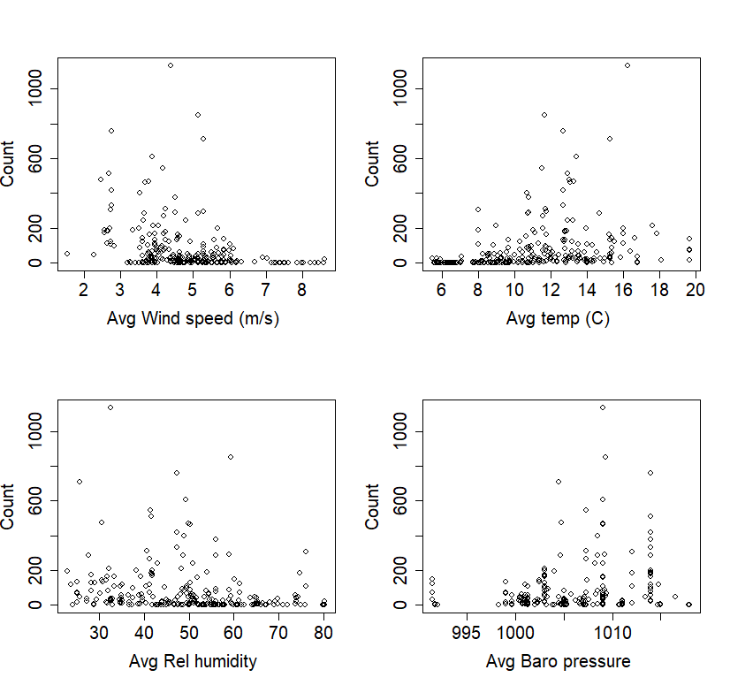

Residuals from neg binomial model with time (^3)

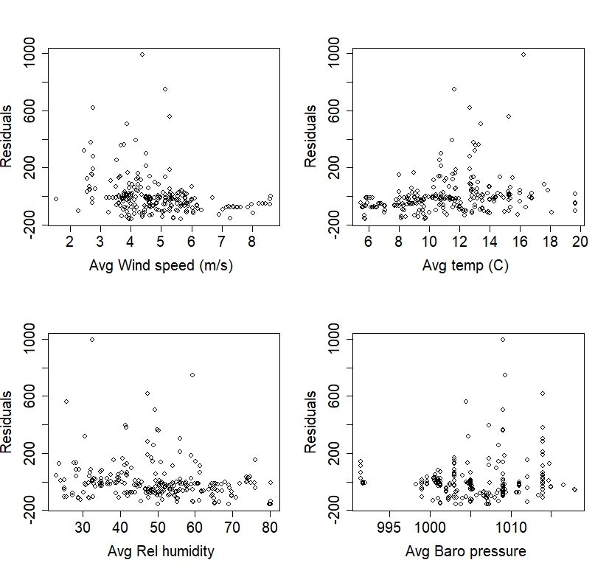

* Means and error bars for each sampling occasion

How does mosquito abundance change across) Daily weather (flight activity)

**Tried candidate models with combinations of time + weather variables. Used AIC to select model.**

null<-glm.nb(Count3.5 ~ 1, data=C02weathertraptime)

Windlinear<-glm.nb(Count3.5 ~ WindSpeedAvg, data=C02weathertraptime)

Templinear<-glm.nb(Count3.5 ~ TempAvg, data=C02weathertraptime)

Tempquad<-glm.nb(Count3.5 ~ TempAvg + I(TempAvg^2), data=C02weathertraptime)

Rhlinear<-glm.nb(Count3.5 ~ Rhavg, data=C02weathertraptime)

Barolinear<-glm.nb(Count3.5 ~ BaroAvg, data=C02weathertraptime)

Timelinear<-glm.nb(Count3.5 ~ Date.num, data=C02weathertraptime)

Timequad2<-glm.nb(Count3.5 ~ Date.num + I(Date.num^2), data=C02weathertraptime)

Timequad3<-glm.nb(Count3.5 ~ Date.num + I(Date.num^2) +I(Date.num^3) , data=C02weathertraptime)

fullmodel<-glm.nb(Count3.5 ~ Date.num + I(Date.num^2) +I(Date.num^3) + WindSpeedAvg + TempAvg+ Rhavg+ BaroAvg, data=C02weathertraptime)

windtime<-glm.nb(Count3.5 ~ Date.num + I(Date.num^2) +I(Date.num^3) + WindSpeedAvg , data=C02weathertraptime)

temptime<-glm.nb(Count3.5 ~ Date.num + I(Date.num^2) +I(Date.num^3) + TempAvg , data=C02weathertraptime)

tempwindtime<-glm.nb(Count3.5 ~ Date.num + I(Date.num^2) +I(Date.num^3) + WindSpeedAvg + TempAvg, data=C02weathertraptime)

tempwindtimeRh<-glm.nb(Count3.5 ~ Date.num + I(Date.num^2) +I(Date.num^3) + WindSpeedAvg + TempAvg+ Rhavg, data=C02weathertraptime)

**> aictable(rawaic,nR)**

**Params logL AICc deltaAICc weight cumwt**

**fullmodel 9 -1126.342 2271.421 0.0000 0.6420 0.6420**

tempwindtimeRh 8 -1128.020 2272.628 1.2063 0.3512 0.9933

tempwindtime 7 -1133.044 2280.544 9.1223 0.0067 1.0000

windtime 6 -1153.976 2320.292 48.8701 0.0000 1.0000

temptime 6 -1162.431 2337.202 65.7809 0.0000 1.0000

Tempquad 4 -1168.770 2345.700 74.2791 0.0000 1.0000

Windlinear 3 -1172.154 2350.404 78.9821 0.0000 1.0000

Timequad3 5 -1176.862 2363.965 92.5438 0.0000 1.0000

Templinear 3 -1179.476 2365.048 93.6263 0.0000 1.0000

Timequad2 4 -1179.241 2366.642 95.2205 0.0000 1.0000

Timelinear 3 -1186.004 2378.103 106.6819 0.0000 1.0000

Rhlinear 3 -1193.468 2393.032 121.6101 0.0000 1.0000

Barolinear 3 -1193.580 2393.256 121.8349 0.0000 1.0000

null 2 -1199.271 2402.591 131.1691 0.0000 1.0000

How does mosquito abundance change across) Daily weather (flight activity)

**Moz abundance decreases with wind speed and barometric pressure, increases with temperature, relative humidity**

> summary(fullmodel)

Call:

glm.nb(formula = Count3.5 ~ Date.num + I(Date.num^2) + I(Date.num^3) +

WindSpeedAvg + TempAvg + Rhavg + BaroAvg, data = C02weathertraptime,

init.theta = 0.4688346402, link = log)

Deviance Residuals:

Min 1Q Median 3Q Max

-2.1462 -1.1243 -0.6401 0.1191 2.9551

Coefficients:

Estimate Std. Error z value Pr(>|z|)

(Intercept) -6.639e+02 2.935e+02 -2.262 0.023676 *

Date.num 1.191e+01 4.897e+00 2.431 0.015037 *

I(Date.num^2) -6.569e-02 2.766e-02 -2.375 0.017549 *

I(Date.num^3) 1.199e-04 5.194e-05 2.309 0.020968 *

WindSpeedAvg -7.539e-01 7.771e-02 -9.701 < 2e-16 ***

TempAvg 4.348e-01 4.998e-02 8.700 < 2e-16 ***

Rhavg 4.366e-02 1.152e-02 3.788 0.000152 ***

BaroAvg -4.937e-02 2.228e-02 -2.216 0.026670 *

---

Signif. codes: 0 ‘***’ 0.001 ‘**’ 0.01 ‘*’ 0.05 ‘.’ 0.1 ‘ ’ 1

(Dispersion parameter for Negative Binomial(0.4688) family taken to be 1)

Null deviance: 480.61 on 253 degrees of freedom

Residual deviance: 289.66 on 246 degrees of freedom

AIC: 2270.7

Number of Fisher Scoring iterations: 1

Theta: 0.4688

Std. Err.: 0.0427

2 x log-likelihood: -2252.6840

How does mosquito abundance change across 3) landscape variation (blood meal density, quantity)

**Traps paired up by trapping time**

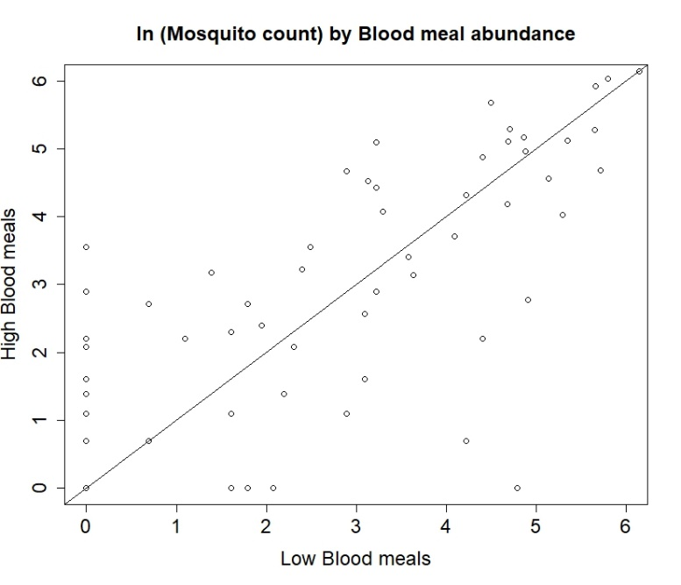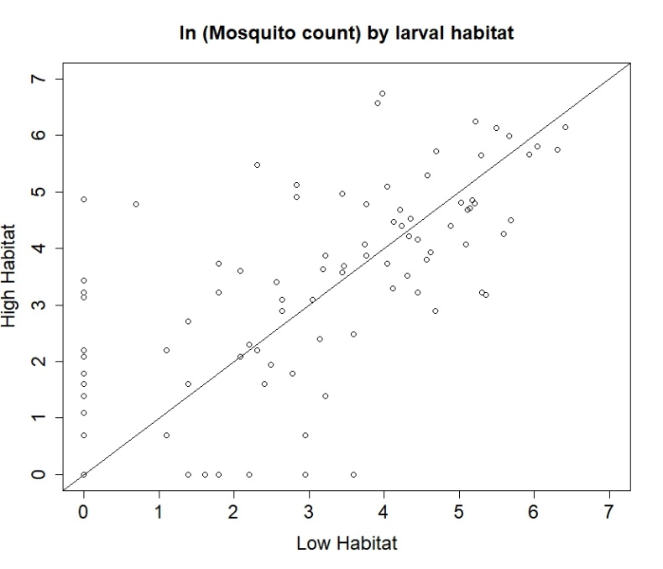

**Comparisons across traps when all 4 categories were on at the same time (HighBm, High hab 🡪 Low BM, Low hab)**

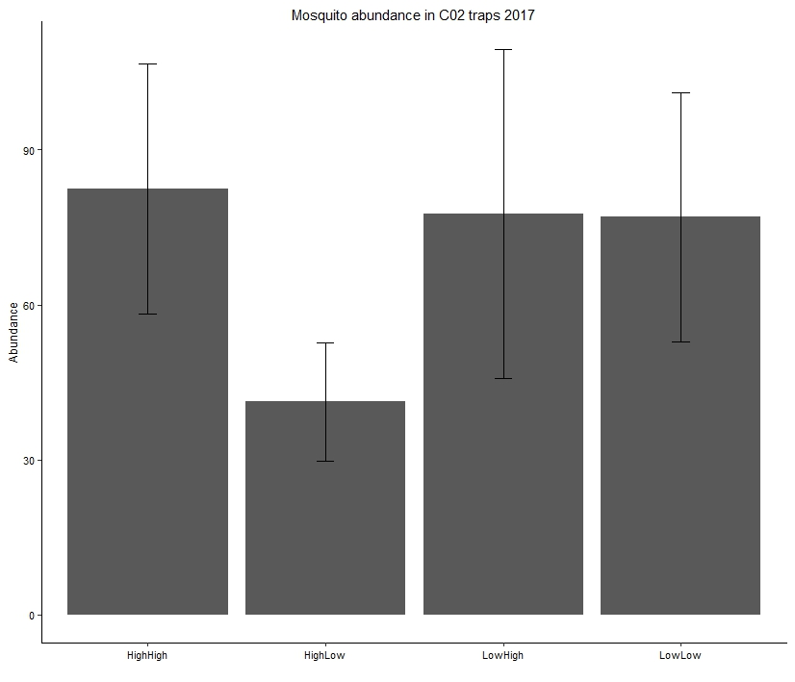

How does mosquito abundance change across 3) landscape variation (blood meal density, habitat quantity)

Blood meals and Habitat as a continuous variable

|  |  |  |  |
| --- | --- | --- | --- |
| **Site** | **ScatCount** | **Habitat amount (m2)** | **Category** |
| Waterfall up | 74 | 402 | HighLow |
| Camp | 20*** | 1495 | LowLow |
| Kforest | 19 | 2331 | LowLow |
| Bunny Hill | 113 | 3580.25 | HighLow |
| VV2 | 31 | 6971 | HighLow |
| Moz valley | 81 | 7469.75 | HighHigh |
| Waterfall | 101 | 8034 | HighHigh |
| KISS | 100** | 8675 | HighLow |
| Seatomato | 35 | 8857 | LowHigh |
| Oil | 10 | 11742.1 | LowHigh |
| VV1 | 71 | 12617.745 | HighHigh |
| Golf | 0 | 27609 | LowHigh |

***dummy variable

**Compared candidate models. Random effect: Site nested within date trap was on. (To compare across sites according to habitat and blood meals adjusting for date of the season). BM and Habitat not significant.**

> HabitatBMmodel<-glmmadmb(Count3.5 ~ Scatcount+ Habitatamount+ (1|Site/Weatherperiod), data=C02weathertraptimesubset,zeroInflation=FALSE, family="nbinom")

> aictable(rawaic,nR)

Params logL AICc deltaAICc weight cumwt

null 4 -952.903 1914.008 0.0000 0.5335 0.5335

BMmodel 5 -952.797 1915.899 1.8905 0.2073 0.7409

Habitatmodel 5 -952.900 1916.105 2.0965 0.1870 0.9279

HabitatBMmodel 6 -952.791 1918.011 4.0026 0.0721 1.0000

> summary(HabitatBMmodel)

AIC: 1917.6

Coefficients:

Estimate Std. Error z value Pr(>|z|)

(Intercept) 1.98e+00 5.06e-01 3.92 8.9e-05 ***

Scatcount 2.62e-03 5.61e-03 0.47 0.64

Habitatamount 3.17e-06 3.05e-05 0.10 0.92

---

Signif. codes: 0 ‘***’ 0.001 ‘**’ 0.01 ‘*’ 0.05 ‘.’ 0.1 ‘ ’ 1

Number of observations: total=203, Site=13, Site:Weatherperiod=203

Random effect variance(s):

Group=Site

Variance StdDev

(Intercept) 3.551e-07 0.0005959

Group=Site:Weatherperiod

Variance StdDev

(Intercept) 7.36 2.713

**Same thing, but excluded any traps where temp < 8C and wind > 6 (because they are all zeros)**

**Habitat and BM still not significant**

> summary(HabitatBMmodel2)

Call:

glmmadmb(formula = Count3.5 ~ Scatcount + Habitatamount + (1 |

Site/Weatherperiod), data = C02weathertraptimesubsettempwind,

family = "nbinom", zeroInflation = FALSE)

AIC: 2044.2

Coefficients:

Estimate Std. Error z value Pr(>|z|)

(Intercept) 3.35e+00 3.83e-01 8.74 <2e-16 ***

Scatcount -2.26e-03 4.12e-03 -0.55 0.58

Habitatamount 6.15e-06 2.32e-05 0.27 0.79

---

Signif. codes: 0 ‘***’ 0.001 ‘**’ 0.01 ‘*’ 0.05 ‘.’ 0.1 ‘ ’ 1

Number of observations: total=188, Site=13, Site:Weatherperiod=188

Random effect variance(s):

Group=Site

Variance StdDev

(Intercept) 1.212e-06 0.001101

Group=Site:Weatherperiod

Variance StdDev

(Intercept) 3.945 1.986

Negative binomial dispersion parameter: 403.43 (std. err.: 1.3092)

Log-likelihood: -1016.1